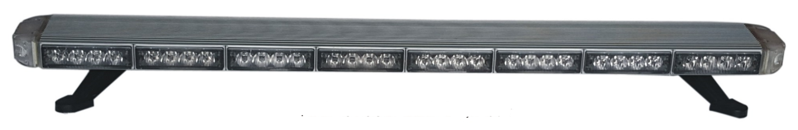
NEC-5400B
18 X 1.5 WATT LED CLUSTERS
ULTRA SLIM AERODYNAMIC DESIGN
CLEAR LENSES FOR STEALTH APPEARANCE
15 SELECTABLE FLASH PATTERNS
UNIVERSAL GUTTER BRACKETS AND ADJUSTABLE FEET
5 BUTTON CONTROL BOX
1035mm STANDARD LENGTH
CUSTOMIZED LENGTHS ARE OPTIONAL
12V AND 24V DC UNITS

